Mark Weir obituary
Entrepreneur who tapped into the tourist potential of the Lake District's slate mines by Martin Wainwright

- guardian.co.uk, Friday 8 April 2011 16.39 BST

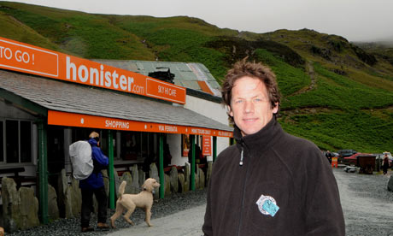
Mark Weir first conceived of a via ferrata when he flew over the disused mine in a helicopter with his grandfather. Photograph: Jeff Morris
Mark Weir, who has died in a helicopter accident aged 45, was an exuberant businessman who brought new life to the ancient slate mines of the English Lake District. Restless and brimming with ideas, in 2006 he installed the UK's first via ferrata, or mountain climbing ladder, high in the fells and was working on plans for a zip line and an underground theatre at the time of his death.
His string of businesses was initially conventional – retirement homes, pubs and fish-and-chip shops – but that changed when he took his grandfather for a helicopter ride in 1985 over the Honister pass between Borrowdale, where he was born, and Buttermere. The old man looked sadly at the recently closed workings of the huge mine and quarry in the flank of Fleetwith Pike, where he had been employed as a river, or cutter, supplying slates to Buckingham Palace.
Peering down himself, Weir saw something different. The huddle of grey buildings, including a spartan youth hostel, had untapped tourist potential, a handy jumping-off point at 356m (1,167ft) for some of England's most famous mountain-tops. With a business partner, Bill Taylor, he bought the mine from McAlpines later that year and set about turning it into one of the national park's leading attractions.
This took his talent for hustling and cheerful promotion to its peak, exasperating planners and sometimes alarming the Lake District's many conservationists. He won most of them over by skillfully linking the demands of modern tourism to Cumbria's industrial tradition, in which his own family had been so closely involved.
While guidebooks rhapsodized about ancient characters such as Moses the quarryman, whose "trod" from Honister round Great Gable is a famous high-level path, Weir actually brought their jobs back to life. His 30 staff at Honister include waiters and shop assistants, but also excavator-drivers whose great yellow machines, looming out of the mist, reassure many nervous navigators on the coast-to-coast walk. The beautiful Westmorland Green slate from the reopened mine is now used to fashion kitchen units, house nameplates and garden features, as well as Weir's playful "coast-to-coasters" souvenir drinks mats, and visitors can watch the miners in action on a guided underground tour.
Weir's hands-on approach also charmed potential opponents. He knew his local history backwards and took personal charge of some of the tours, which now bring in 60,000 visitors a year. He famously offered large, free mugs of tea to soaked or shivering ramblers, gently nudging them towards the mountain rescue donation box instead.
In the 1990s he expanded to offer spooky tours of miles of cavern and tunnel, and then came the heady experience of the via ferrata along the beetling walls of Honister crag.
Weir had a background familiar in natural entrepreneurs. He left school in Keswick through boredom at 16 and set himself up as a one-man business, offering everything from farm labouring to grave digging shifts. Fell-walking inspired him, with the notion of learning to fly to get even better views. He obtained a pilot's license in the early 1980s.
This led in turn to a helicopter hire company and a love of whirling around his dramatic neighbourhood. A careful and experienced pilot, he also had an adventurous streak that led to a £400 fine in January 2011 for an unauthorised stunt, dropping the champion paraglider Felix Rodriguez from 3,050m (10,000ft) to perform an "infinite tumble" at last year's Lakes Charity Classic airshow.
He died after leaving work on his routine commute when the Gazelle helicopter came down only 200m (655ft) from the mine en route to the home near Cockermouth that he shared with his partner, Jan Wilkinson, and their three children, who all survive him. Among many local tributes, the writer and broadcaster Eric Robson, who chairs Cumbria Tourism, spoke of the "tremendous joy" Weir brought through ideas that he "pushed through when everyone else was saying you can't do that or you'll never get away with it". The mine will continue in family ownership.
• John Henry Mark Weir, entrepreneur, born 30 January 1966; died 8 March 2011

